Set up everything you need in this course:

Install Python 3
1. Download Python from python.org/downloads/
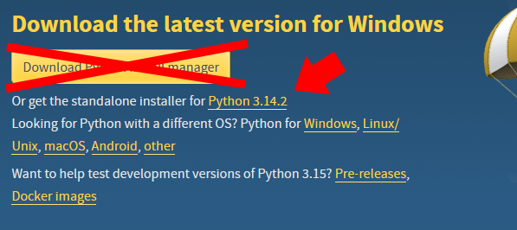
2. Run the downloaded file.
3. Tick both “Use admin privileges” and “Add python.exe to Path”, then choose “Customize Installation”. Click Next.
4. Deselect “Tcl/Tk, turtle and IDLE”, “Python test suite”, “py launcher” and optionally “for all users”. Click Next.
5. You can keep all standard ticks, if you want, you can also “select Install for all users” and select a different location. It is important to later know where you installed Python.
6. Click Install and wait for it to finish. You can choose to disable path length limit, but you don’t have to. Then close the installer
Congrats! You installed Python!

Install VS Code
1. Download Python from code.visualstudio.com
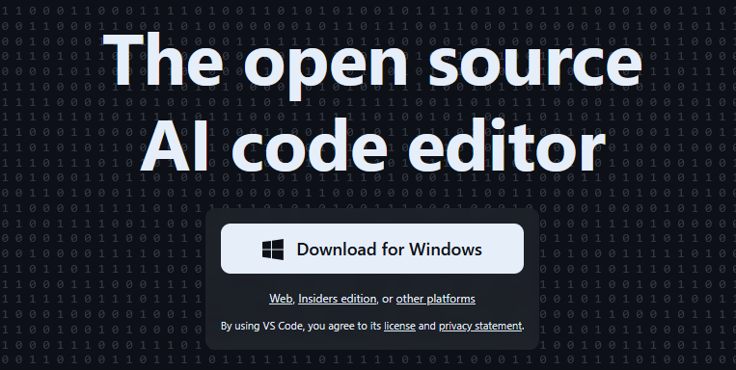
2. Run the downloaded file.
3. Accept the terms and conditions (without reading them).
4. Choose an installation folder.
5. Choose if you want to have a start folder
6. Keep the pre-selected options, optionally select desktop symbol.
7. Click Install and wait until it’s finished.
8. Deselect “start VS Code”, and close the Installer. Now restart your PC so the correct connections can magically be made by our robot overlords.
Congrats, you installed VS Code!

Setting up VS Code
1. Open VS Code (Windows shows it as just Code if you need to search for it).
2. Close the automatic setup screen. Look at the upper left corner. There are the vertical submenus “Explorer”, “Search”, “Source Control”, “Run and Debug”, and “Extensions”
3. Go to “Extensions”. Search for and install the following extensions:
- Python python language support
- Python Debugger python debugging support
- Python Environments environment for python packages
- Pylance integrated documentation and other improvements
Otional: - autoDocstring cool tool for faster documentation
- vscode-pets helps you cope with frustration
4. Go to “Files”. Click “Open Folder”. Create a Folder called something along the lines of “My python projects”. Create a subfolder named something like “Coding Workshop”. This structure will help you organize your future coding adventures. Each project should have its own folder.
5. Go to “File” in the horizontal menu and create a “New File…” Select Python File from the dropdown menu.
6. In this file, write “print(‘Hello world!’)” Now press F5 on your keyboard. Select your previously created folder as a saving destination and give your file a name.
7. In the new dropdown menu, select Python Debugger, then Python File.
8. If you find the sentence “Hello World!” in a newly opened terminal, you are good to go. Otherwise, ask for help.
Congrats, you set up VS Code!

Create a virtual environment
1. Open the explorer and go to your “Documents” location. Create a folder called “python _virtual_environments”. Create a subfolder “coding_workshop_venv”. (“venv” stands vor Virtual ENVironment)
2. Go back to VS code and go into the Terminal. Enter the following command:
python -m venv C:/Users/[your username]/Documents/python_virtual_environments/coding_workshop_venv
Hint: if your Username has a space in it, please use “[your username]”. Also in the real message, don’t use the brackets, they just indicate a placeholder here.
3. wait. Then when the dropdown menu appears, select “Find…” and navigate to your folder. Then go into the folder “Scripts” and select python.
4. Wait until the environment is chosen.
Congrats, you set up a virtual environment!

Add version control
1. Create an Account on GitHub at github.com/signup
2. Download GitHub Desktop from desktop.github.com/download
3. Run the downloaded file
4. Sign in with your account, follow the instructions and click Finish
Congrats, you installed GitHub Desktop

